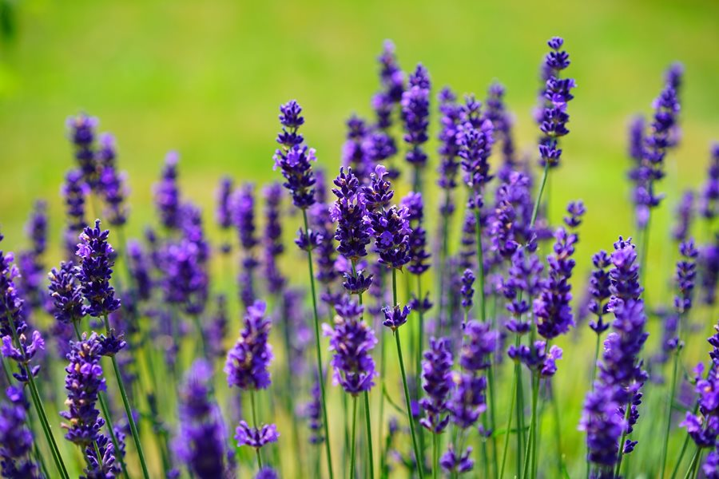
Credit: https://www.gardendesign.com/plants/lavender.html
Nectar Source: Lavender Bush
Location: 30 feet away from the hive
Richness of Nectar Source: Low amount of sugar
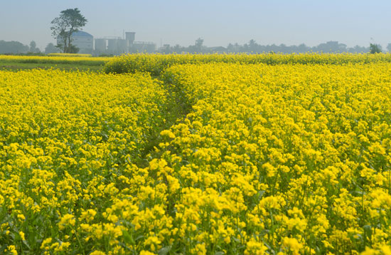
Credit: © towfiqu/Fotolia
Nectar Source: Yellow Mustard Plant
Location: 1 mile away from the hive
Richness of Nectar Source: High amount of sugar
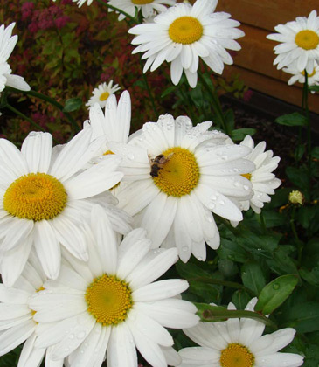
Credit: http://beefriendly.ca/25-plants-for-bees-in-your-garden/
Nectar Source: English Daisy
Location: 1/2 mile away from the hive
Richness of Nectar Source: Low amount of sugar

