Objective: Students will explore the honey bee’s life cycle, anatomy, social life, and its “art” of honey production. The purpose of honey bee education is to evoke feelings of appreciation for the honey bee and passion toward its conservation. (Audience: 2nd Graders-4th Graders)
Overview: This lesson plan is designed as an instructional guide to teach educators about honey bees, so they can teach the included honey bee lesson without having a lot of background knowledge on honey bees. The lesson plan contains 2 interactive games, 1 craft, and information for 2 honey bee discussions along with a time estimate for each activity. The lesson should take about 2 hours.
The honey bee talks include guiding questions which the educator can ask the class in order to make the lesson more interactive. Each honey bee icon marks a different activity. All of the additional materials needed for the lesson are highlighted in green for PowerPoints and yellow for craft materials. These materials can be found on the Abuzz for Honey Bees website: https://abuzzforhoneybees.weebly.com
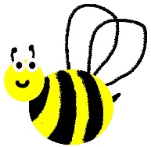
A. Discussion – Honey Bees Are Social Insects

Guide:
- Have students gather on the carpet.
- Use Abuzz for Honey bees Day 2 PowerPoint
- Use photographs on the PowerPoint and guiding questions (below) in order to teach the different types of honey bees, the honey bee lifecycle, and how honey bees function as a social colony. A teaching hive or observation hive can be used as a visual aid if available.
- Time~20 minutes
Ask:
1. Where do honey bees live? (Slide 3)
Honey bees are like an extended family made up of drone bees, worker bees, and queen bees. Honey bees live with their family inside of a hive structure made of wooden frames (provided by the beekeeper), beeswax combs (built by the bees), and propolis (bee-produced glue used to fill crevices and help the bees walk on the combs). The hive functions as a place for the honey bees to store honey, raise brood (their young), and find shelter. Imagine living with 50,000 brothers and sisters in the same house; this is how honey bees live in the hive.
2. Do honey bees have to eat a balanced diet, like people? (Slide 4)
Workers bees and drone bees (we will address queen bees later) eat pollen, honey, and nectar. Just like people, honey bees need a balanced diet. The pollen serves as a source of protein: similar to how meat and beans serve as protein for people. Honey bees have to forage for nectar and pollen from a wide variety of flowers in order to gain all of the necessary vitamins and minerals. Different flower sources have different amounts of vitamins and minerals. Nectar and honey serve as a source of carbohydrates; this is similar to how bread, pasta, rice, etc. serve as carbs for people. Honey bees eat nectar from flowers during the spring and summer when nectar is plentiful. Honey bees eat honey (stored in the hive) during the winter when nectar flow is scarce. The honey bee’s use of honey is like how people eat frozen or canned foods when fresh ones aren’t available. Honey bees also have to drink water.
3. How are honey bee colonies like a soccer team? (Slide 5)
One could say that bees are the ultimate example of teamwork and selflessness because all of their work goes towards helping the colony survive. Every honey bee has its own job. This allows honey bees to be very efficient at making honey versus each bee doing all of the tasks themselves. A single honey bee would not be able to clean the hive, feed young, build cells, guard the hive, and gather enough food to survive. This is similar to how every player on a soccer or basketball team has their own role such as offense, defense, goalie, etc. You can’t win a soccer game without your team; likewise, a single honey bee cannot survive on its own. This is why honey bees are known as truly social insects (eusocial). Eusocial insects share three characteristics including cooperative care of young, reproductive division of labor, and generation overlap.
4. What is the job of drone bees? (Slide 6)
Drone bees are the only male honey bees. They are bigger than worker bees and have larger eyes. Drones don’t do any work for the honey bee colony. All they do is gorge themselves on honey and pollen which is fed to them by female worker bees. In fact, their only role in the honey bee colony is to mate with the queen. Drone bees are so lazy and unproductive that the female worker bees kick them out in the winter in order to save food.
5. Does anyone know where the saying “busy as a bee” comes from? (Slide 7)
Worker bees are one type of female honey bee. Worker bees are always busy doing some sort of task for the bee colony; this is where the phrase “busy as a bee” comes from. Every worker has a job based on it age. For example, 1-2 day old workers are the maids of the hive (clean cells), 3-11 day old workers are the waitresses of the hive (feed larvae), 12-17 day old workers are the carpenters (produce wax and build combs), 18-21 day old workers are the hive guards (protect the hive with their lives against intruders like wasps), and 22+ day old workers are forager bees (gather nectar, pollen, and water for the colony).
6. Why is the queen bee called a “queen”? (Slide 8)
Queen bees are the other type of female honey bee and the largest honey bee in the colony. The queen bee truly is the royalty of the colony because only she can lay worker bee eggs. The queen is also the boss of the colony because of her ability to produce special chemical signals (called queen pheromones) which control the behavior of the colony. This queen pheromone is spread throughout the colony of worker bees through direct contact. The queen pheromone signals for behaviors such as preventing new queens from being raised, controlling foraging, controlling comb building, and more. There is only one queen bee per colony, and the queen even has her own attendants. The attendants are worker bees that bathe, feed, and protect her. The queen bee can live up to 4 years (worker bees only live a few weeks) because she is fed a special diet of royal jelly her entire life.
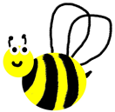
B. Honey Bee Craft

Guide:
- Print copies of Bee Coloring Pages for whole class
- Print copies of Day 2 Honey Bee Craft Description Cards for whole class
- Materials: popsicle sticks (preferably the thicker ones, shown in the picture below)
- Time~30 minutes
Directions:
- Have students pick the type of bee that best represents themselves-either a worker, queen, or drone bee. (If the student picks worker bee, have them pick a specific type of worker bee such as a forager, queen attendant, etc.) Show them an example of a finished honey bee craft.
- Have the students color the honey bee that they selected.
- Have the students glue the Description Cards to the colored honey bee.
- Have the students explain how the honey bee represents themselves on the back (using the description card).
- Have the students attach the honey bee to a popsicle stick.
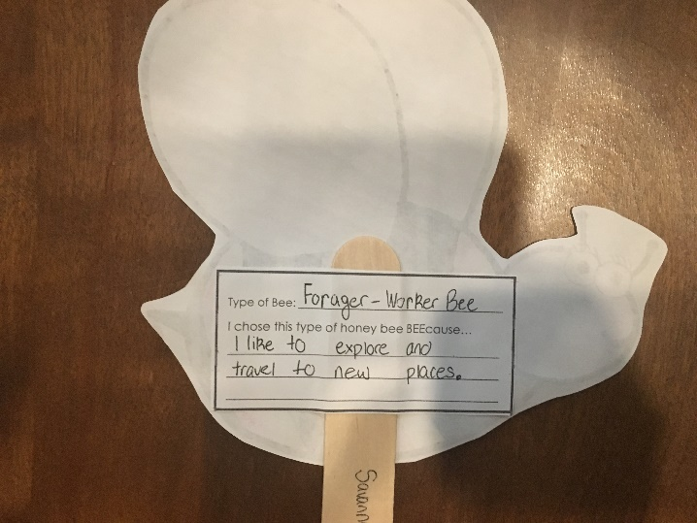
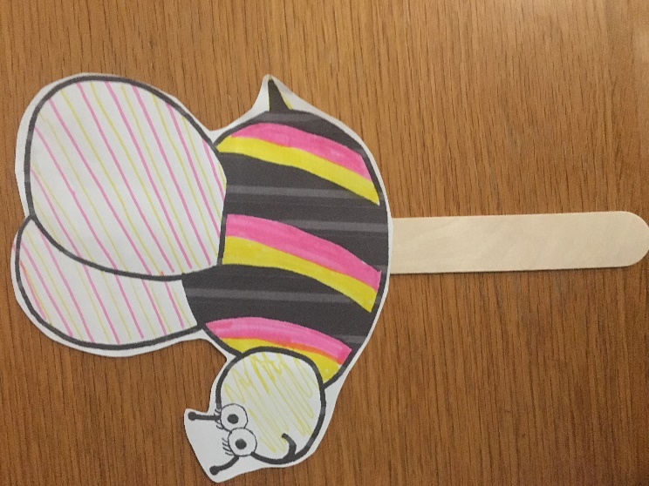

C. Discussion– The Art of Making Honey

Guide:
- Have students gather on the carpet
- Use Abuzz for Honey bees Day 2 PowerPoint
- Use guiding questions (below) and the PowerPoint to explain how honey bees make honey using their unique body parts.
- Time~20 minutes
Ask:
1. What specific body parts of the honey bee help it to harvest and process nectar? (Slide 10)
The anatomy of the honey bee is specifically designed to help it gather nectar and pollen from plants. For example, pollen baskets are stiff hairs on its hind legs which allow it to gather pollen as it flies from flower to flower feeding on nectar. Its proboscis is like a straw which helps the bee slurp up nectar. The honey stomach is filled with special chemicals called enzymes which help the honey bee convert nectar to honey by breaking it down and thickening it.
2. Why do you like flowers? (Slide 11)
Honey bees like flowers for a lot of the same reasons that you do. The flowers attract honey bees through their patterns, colors, scents. While it may seem unimportant to us humans that roses, tulips, apple blossoms, and rosebuds look and smell different, it is very important for bees. This is because they use the color and scent to determine how much nectar the flower holds. The bee’s compound eyes allow it distinguish between patterns. The bees also have special UV photoreceptors which allow them to see colors made up of ultraviolet rays that are invisible to humans (see image below). These colors and patterns lead bees to the nectar. A bee is always thinking “Show me the nectar, show me the nectar…” Honey bee activity depends on nectar flow and pollen from plants (which is available based on when plants are in bloom).

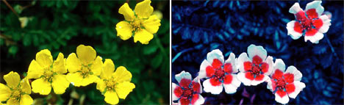
Credit:Norwegian scientist-cameraman Bjorn Roslett
3. How is the nectar processed into honey once the honey bee brings it back to the hive? (Slide 12)
- Once the forager bee gathers all of the nectar and pollen that it can carry, it flies back to the hive and does a specific type of dance to show the other bees where the flowers are.
- The forager bee then “throws up” the nectar from its honey stomach. It transfers the nectar to a hive bee using its proboscis. The nectar is further processed by the hive bee’s honey stomach.
- The hive bee then blows a nectar bubble; this helps convert the nectar to honey through evaporation.
- The honey bee then stores the nectar in beeswax cells in order to further ripen the honey. Evaporation lowers the amount of water in the nectar.
- Once the nectar has been completely ripened through evaporation, a hive bee caps the honey with a beeswax covering. The bees have now finished the honey making process.
4. Does honey ever go bad? (Slide 13)
The finished, capped honey will never go bad. Honey technically lasts forever because of its high sugar and acid content, thickness, and special chemicals called enzymes. These factors prevent the growth of tiny, food-spoiling organisms called bacteria. 5,000-year-old honey (that is still edible) has been found.
5. If mankind were to harvest nectar and ripen it through evaporation, would we be able to make honey? (Slide 14)
Although these factors are involved in making honey, we forgot the KEY to making honey-the honey bee. Even though mankind can harvest nectar and evaporate water from it, we can’t replicate the same honey-making processes that go on inside of the honey bee. We don’t have the sucrase and glucose oxidase enzymes, present in the bee’s honey stomach, which help to break down the complex nectar sugars into simpler sugars. This is yet another reason why honey bee conservation is so important. A world without honey bees would lack honey, a natural sweetener which can be used in bread, baked goods, salad dressings, meat glazes, and a countless number of other foods. Honey can also be used in gum, wound dressings, soap, allergy medicine, and other products.

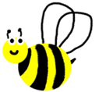
D. Honey Bee Communication Dance

Guide:
- Use Nectar Source Info Cards for Honey Bee Communication Dance
- Materials: blue painter’s tape
- Time~20 minutes, optional activity if time allows
Directions:
- Explain the round dance and waggle dance to the class using explanations below*.
*The round dance is used to say, “hey foragers, the nectar is really close to the hive”. The honey bee runs around in circles with quick, short steps and often changes directions. As the honey bee dances faster, this means that the nectar has a higher concentration of sugar. The smell of the food source sticks to the forager bee as it is dancing which helps to communicate the flower’s location. The honey bee may also pause during the dance to allow other bees to taste a sample of the nectar. For the round dance, have the class stand in line and hold hands. Then, have everyone move in a circle counterclockwise and clockwise.
*The waggle dance is used to communicate the location of nectar that is far from the hive. The direction of the waggle points towards the location of the food source in relation to the sun, and the length of the waggle communicates how far away the food is. The speed of the waggle communicates the richness of the nectar (like in the round dance). For the waggle dance, first mark out the path (see diagram below) with painter’s tape. Then, explain how the class will sidestep along the outside path and “waggle” in the middle.
- Have the class pretend that they are honey bees.
- Read the nectar source info cards (attached with this lesson plan) to the class and ask the class guiding questions (below) to determine which dance to perform.
-Is the nectar source rich in sugar or does it have a low amount of sugar?
-Is the nectar source (flowers) close to the hive or far away?
-If the nectar source is far away, what direction is it in?
- Have the students perform the communication dance as a class (do it with them).
Credit: https://climatekids.nasa.gov/bees/
E. Forager Bee Game

Guide:
- Use Day 2 Signs for Game
- Take class to an outside courtyard or other open space to play this game
- Materials:
-6 pool noodles (3 orange, 3 red) chopped into 60 pieces (chop each noodle into 10 pieces) *can use tiny balls, rubber chickens, or other small item if noodles aren’t available
-3 full size pool noodles (color doesn’t matter) divided in half
-6 hula hoops (at least 3 different colors)
-3 paper signs saying “Guard Bee”, one saying “Bear”, one saying “Kid”, one saying “wasp” (use Day 2 Signs for Game)
- Time~40 minutes
Directions:
1.) Ask for 3 volunteers, these 3 students will either be the bear, kid, or wasp. Tape the appropriate sign to each child and give them each a half sized pool noodle. Explain to these students that their goal is to chase forager honey bees (other classmates) carrying nectar and pollen. If they gently tap the forager bee below the knees with their noodle, then the bee has to put the noodle piece back in a center cluster of “flowers”.
2.) Divide the remaining students into 3 groups. Have the students imagine that they are honey bees and that each group represents a honey bee colony. Ask which member from each group wants to be the “Guard Bee”. Tape the appropriate sign to each child and give them each a half sized pool noodle. Explain to the guard bees that they will guard their honey bee colony’s supply of nectar and pollen (symbolized by chopped up pool noodles). If a forager bee tries to rob their supply, they can gently tap the bee below the knees with their half-sized pool noodle and the bee will have to put the noodle piece back in the center cluster of “flowers”.
3.) Explain to the students that their goal is to harvest as much nectar and pollen as they can (represented by the chopped up pool noodles) and bring it back to their hive. Each hula hoop in the center represents a cluster of flowers containing nectar and pollen. Students can either harvest nectar and pollen from the center cluster of flowers, or they can steal nectar and pollen from nearby bee hives (representing how honey bees sometimes rob other hives).
4.) After 3 minutes (this time period can be changed based on the age and speed of the students), stop the game. This is the end of round 1. At this point, take away 10 noodle pieces from the center. Say something like “Oh no, several wild flowers have been mowed over and now there is less nectar and pollen!” Then, resume the game.
5.) After 3 minutes, stop the game because this is the end of round 2. At this point, take away 15 noodle pieces from the center. Say “Sadly, many families didn’t plant gardens this year and now the honey bees will have less to eat!” Then, resume the game.
6.) After 3 minutes, stop the game because this is the end of round 3. At this time, add 15 noodle pieces back to the center. Say “Fortunately for the bees, many families and schools have planted honey bee friendly gardens so the honey bees have more to eat!”
7.) After 3 minutes, end the game. Have each team count the amount of nectar and pollen that they harvested. Explain to the students that the bee colony with the most noodle pieces wins the game and will survive the winter. However, the rest of the colonies won’t make it through the winter. *The teams can be switched and roles changed at this point. The game
can be repeated as much as time allows.

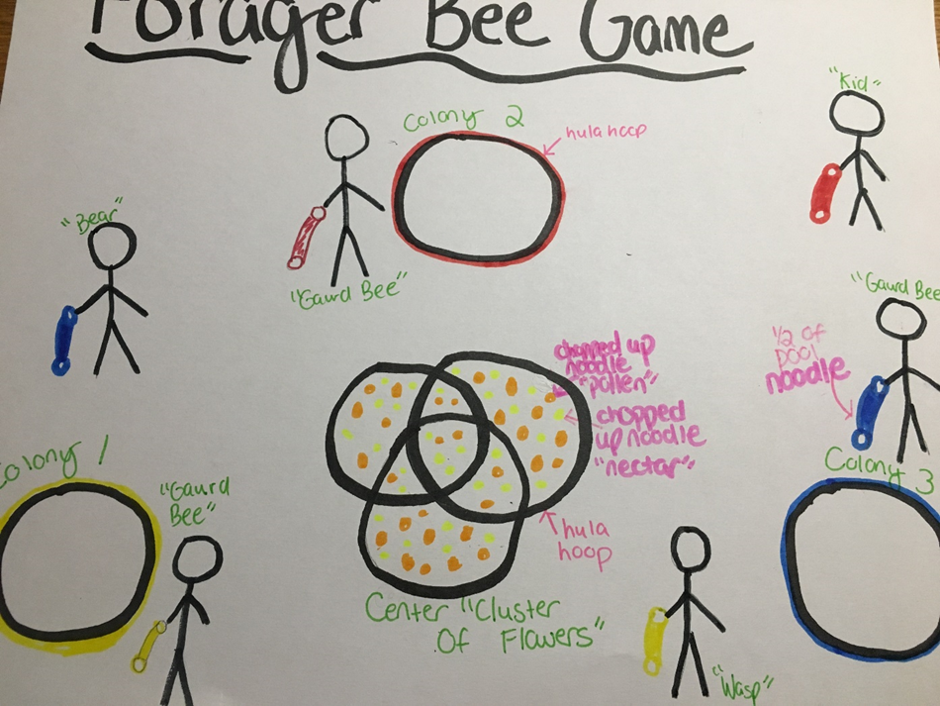

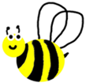
F. Wrap-Up

Guide:
- Have students gather on the carpet
- Use Abuzz for Honey bees Day 1 PowerPoint
- Time~20 minutes
Ask:
1. What happened during the forager bee game?
(any details are acceptable)
2. What made it hard to harvest nectar and pollen (noodle pieces)?
-guard bees (students whose job was to guard their team’s hive)
-robber bees (when other teams would steal noodle pieces)
-predators (“wasp”, “bear”, “kid”)
-removal of wild flowers and habitat destruction (when noodle pieces were removed from the center before rounds)
3. What made it easier to harvest nectar and pollen?
-planting pollinator gardens (when noodle pieces were added back to the center before rounds)
4. What did this game teach you about honeybees? (reflection)
(any comments are acceptable as reflection)
Use Abuzz for Honey bees Day 1 PowerPoint (slides 6-14) to review why bees are endangered and what students can do to help honey bees.

REFERENCES:
Blackwell, N., & Ettinger, C. (2013). Andy the Ant Learns the Buzz on Bees. North Fort Myers, FL: Faithful Life.
Caron, D. M., & Connor, L. J. (2013). Honey Bee Biology and Beekeeping. Kalamazoo, MI: Wicwas Press.
Delaplane, K. S. (2018). First Lessons in Beekeeping. Mineola, NY: Dover Publications.
Julivert, A. (1986). The Fascinating World of Bees. Moscow: Mir.
Kennedy, M. (2016, October 03). Bees Added To U.S. Endangered Species List For 1st Time. Retrieved January 15, 2018, from https://www.npr.org/sections/thetwo-way/2016/10/03/496402620/bee-species-added-to-u-s-endangered-species-list-for-1st-time
Rossman, S. (2017, May 27). A third of the nation's honeybee colonies died last year. Why you should care. Retrieved January 15, 2018, from https://www.usatoday.com/story/news/nation-now/2017/05/26/third-nations-honeybee-colonies-died-last-year-why-you-should-care/348418001
Sarich, C. (2013, August 15). List of Foods We Will Lose if We Don't Save the Bees. Retrieved January 16, 2018, from https://honeylove.org/list-of-food/
Sass, Jennifer. “Why We Need Bees: Nature’s Tiny Workers Put Food on Our Tables.” Bee Facts, Natural Resources Defense Council, 3AD, 2011, www.nrdc.org/sites/default/files/bees.pdf.
Usha, Jyoti, B., & Singh, P. (2015). Honeybees and their importance in sustaining life on earth.
Rashtriya Krishi, 10(1), 1-2. Retrieved January 17, 2018, from http://www.researchjournal.co.in/upload/assignments/10_57-58.pdf
What is a neonicotinoid? (2017, March 5). Retrieved January 16, 2018, from https://citybugs.tamu.edu/factsheets/ipm/what-is-a-neonicotinoid/

Standards of Learning Addressed:
2.5 The student will investigate and understand that living things are part of a system. Key concepts include a) living organisms are interdependent with their living and nonliving surroundings; b) an animal’s habitat includes adequate food, water, shelter or cover, and space; c) habitats change over time due to many influences.
2.8 The student will investigate and understand that plants produce oxygen and food, are a source of useful products, and provide benefits in nature. Key concepts include a) important plant products are identified and classified; b) the availability of plant products affects the development of a geographic area; c) plants provide oxygen, homes, and food for many animals.

